HILOTHERM Homecare Operating Instructions
HILOTHERM Homecare Type HTP1
Table of Contents
1. General Description
- 1.1 Purpose
- 1.2 Fields of Application
- 1.3 Indications and Contraindications
- 1.4 Requirements for Operator
- 1.5 Machine Description
2. Safety Instructions
- 2.1 General Safety Instructions
- 2.2 Hazard Instructions
- 2.3 Electromagnetic Compatibility
- 2.4 Ambient Conditions
3. Startup Procedure
- 3.1 Function Check
- 3.2 Positioning the Machine
- 3.3 Switching on for the first time and after changing water
- 3.4 Filling and Switching on
- 3.5 Setting T emperature
- 3.6 Connecting the Cuffs
- 3.7 Stopping
- 3.8 Malfunctions
- 3.9 Menu
4. Cleaning and Disinfection
- 4.1 General
- 4.2 Machine Surface
- 4.3 Cuffs
5. Technical Service and Maintenance
- 5.1 Replacing the Water Filter and Water Exchange
- 5.2 Cleaning the Heat Exchanger
- 5.3 Greasing the Plug Connections
- 5.4 T echnical Service
- 5.5 Safety Related Inspections
- 5.6 Liability
- 5.7 Warranty
6. Storage, Transport, Disposal
- 6.1 Storage
- 6.2 Transport
- 6.3 Disposal
7. Technical Data
- 7.1 T echnical Data
- 7.2 Icons
- 7.3 Safety Standard
- 7.4 Errors and Troubleshooting
8. Accessories and Spare Parts
9. Cuffs
- 9.1 Variants and Material Properties
- 9.2 Warnings
- 9.3 Field of Application
- 9.4 Risk Classification
- 9.5 Description of Application
- 9.6 Storage and Transport
- 9.7 Disinfection, Cleaning and Drying
- 9.8 Checkup
- 9.9 Packaging
- 9.10 Sterilisation
10. Annex
A. Declaration of Conformity
Before putting the Hilotherapy system into operation, carefully read the operating instructions. Pay special attention to the instructions labelled Caution and Warning.
Caution describes a situation leading to possible damage to the device or the attached modules.
Warning describes a situation leading to possible damage to persons.

1. General Description
1.1 Intended
The therapy device Hilotherm Homecare HTP1 is used for treating, alleviating and compensating localised injuries, diseases and their after-effects by means of a mild and constant cold. The cold is transferred through the skin by placing cuffs on the area of the body to be treated (e.g. a face cuff below for cooling after jaw surgery).
The benefit of the device is always achaived when a cooling effect is applied to the area of the body to be treated through the cuff, reagardless of how large the temperature difference is between the cuff and body surface.
The temperature can be individually adjusted from + 15 °C to + 22 °C. The device is designed for continuous operation.
The Hilotherapy system is not suitable for reducing (hypothermia) or raising a patient's core body temperature.
1.2 Fields of Application
The Hilotherapy system may be used in various medical areas in the acute phase as well as the remodelling phase, and can effectively help chronically ill patients (e.g. with rheumatism, arthrosis, migraine).
Fields of application
Surgery: Microsurgery, plastic surgery, vascular surgery, orthopaedics, trauma surgery, oral and maxillofacial surgery, oral surgery, oral implant surgery, ENT medicine, dermatologic surgery etc.
Sports medicine / Functional rehabilitation / Physiotherapy: Mobility improvement, pain reduction, muscle relaxation, distortions, muscle strains, muscle tears, sprains, tendon inflammations, bruises, oedemas
Rheumatology: Inflammatory rheumatism, Algodystrophic syndrome, Ischialgia
Other: Dermatology (laser treatment, liposuction, wrinkle injection, photodynamic therapy), emergency medicine, fever, migraine and tension headache
Recommended temperature settings
A successful therapy can be achieved at a temperature setting of 15 °C to 22 °C.
Recommendation
The therapy should be started with a setting of 18°C. The temperature setting can be raised or lowered depending on the sensitivity of the user (too cold or too hot). It is important to have consistently uniform cooling. The temperature of the sleeve should feel pleasantly cool.
Duration of application
The therapy should be continued for as long as the swelling or pain persists.
1.3 Indications and Contraindications
Indications for Hilotherapy
The indications for the use of hilotherapeutic measures are based on the ideas of the physiological mode of action of cold applications. The cold-induced adaptation processes, which occur on several levels in an interlinked manner, can be assigned to two principles of action: Depending on the temperature of the cold medium and the application time, more initial effects are being relayed with regard to vasomotion, pain and ⟨alpha-gamma-motor neuron activity. A longer period of temperature decrease exposes subjacent structures and layers of tissue to the direct cold effect. Thus, the re-warming period varies accordingly.
Important factors in the intensity of the local and systematic effects of a cold stimulus are - besides the temperature and duration of the application - the physical properties of the cold medium, the initial skin temperature and its thermal conductivity as well as the area of the body and the size of the application area. The significance of this distinction lies in the necessity to clearly differentiate between the various forms of cold applications and levels of cooling and to apply them according to the findings and in a purpose-oriented manner.
For disease patterns with an emphasis on analgesic and muscle tone reducing therapy, the hilotherapeutical procedures are essential elements in pre-treatment or interval treatment.
Contraindications of Hilotherapy
Regarding contraindications, we also have to differentiate between „cold“ and „ice-cold“.
With consideration to the primary disease, the contraindications are put into perspective according to the levels of cold. Some diseases, for which the application of ice or comparable media is contraindicated, can be effectively treated with somewhat milder forms of cold. All forms of cold applications are considered to be contraindicated for the emergence of cryoglobulin anaemia, cold haemagglutination and cold urticaria /cold contact urticaria caused by histamine release. Also contraindicated for Hilotherapy are diseases from the range of functional circulatory disorders (e.g. M. Raynaud), severe arterial obstructions, pronounced sensibility disorders and trophic tissue lesions. Provided adequate precautions are taken, mild cold stimuli can be applied for arterial circulatory disorders, mild forms of sensibility disorders and for patients with angina pectoris.
Caution: In patients with compartment syndrome, it is absolutely required to make sure the cuffs are applied without compression to avoid accelerating the already existing pressure increase and the accompanying perfusion disorder.
1.4 Requirements for Operator
Operation of the Hilotherapy system is simple and can be carried out by nursing staff or by the patients themselves. However, the application should be supervised by qualified medical personnel.
The operators shall familiarise themselves with the operating instructions and the device before initial operation. The application of the cuff in particular must be carried out with care.
1.5 Machine Description
The Hilotherapy system HTP1 is a mobile device for localised, professional cold treatment. It distinguishes itself by its simple handling and ease of operation.
The temperature setting is adjustable from + 15 °C to + 22 °C.
Sensors record the actual temperature in the cooling system. The time it takes to reach the target temperature depends on the ambient temperature and the size of the cooling cuffs attached. It may be that the set temperature is not reached with ambient temperatures above 25°C or large cuffs. The accuracy of the temperature control is +- 1°C.
Basically, the Hilotherapy system consists of the following components:
Liquid Air Modul: The Liquid Air Modul serves to precisely control and maintain the temperature of the distilled water according to the chosen values.
Control unit: Through the device’s sensors, the control unit acquires the current data and records them. It also controls the machine’s processes. The desired temperature values are entered via the keys (pos. 04).
Display: The display (pos. 03) shows the set values and the current operating condition.
Cuffs: The cuffs transfer the cold / heat to those body regions to be treated by pumping distilled water at a certain temperature through the cuffs.
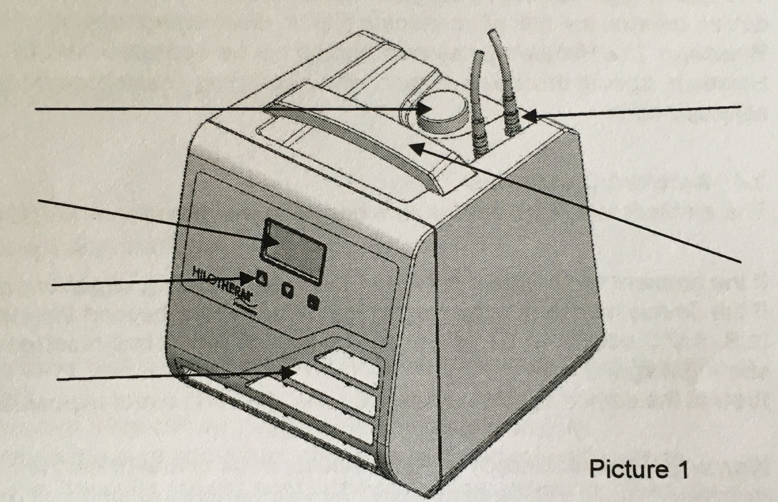
01 Couplings
02 Fillling hopper
03 Display
04 Keypad
05 Venting slots
06 Carrying handle
2. Safety Instructions
2.1 General Safety Instructions
- Before machine startup, the operator has to check if the device and the application parts are in a proper state.
- The therapeutical system always consists of a Hilotherapy device, duo hose and cuff(s).
- Use and connect only the original Hilotherapy devices and cuffs.
- The cuff must be removed if it cannot be used as intended because of fault.
- During treatment, especially when using several or large cuffs, the patient’s body temperature should be monitored.
- The Hilotherapy system must not be used within an incubator.
- The cuffs may be damaged by sharp objects.
- The proper flow through the cuff channels may be obstructed by folding or compressing the cuffs.
- The flow through the tubing may be obstructed by kinks.
- Only fill up the tank with demineralised water.
- When filling up the tank with demineralised water, disconnect the device from the mains.
- Do not block or cover the venting slots on the front and rear panels.
- The device may only be operated when positioned on a level and flat surface.
- The device may only be used when all units and displays are working properly.
- In case of failures, switch the device off immediately. Only after the failure condition was rectified, the machine may be used again. Please inform the manufacturer of any kind of critical or unclear errors.
- Warning! It is not permitted to modify the device.
2.2 Hazard Instructions
- Do not open the housing.
- Prior to maintenance, disconnect the device from power supply.
- Machine maintenance may only be carried out by a qualified service technician.
- The AC voltage source must comply with the data given on the type plate attached to the back of the machine.
- To ensure fire protection, make sure when replacing the fuses that only the same type of fuses with the same nominal values are used (refer to type plate).
2.3 Electromagnetic Compatibility
In electrical medical appliances, particular attention is to be given to the electromagnetic compatibility (EMC), that is the device is to be installed and commissioned according to the EMC- directions contained in this operation instructions (please see instruction and manufacturer’s declaration in the annex).
Portable and mobile radio communication devices may interfere with the operation of medical appliances.
The use of high-frequency surgical instruments or endocardial catheters with an active medical device creates the risk of an electric shock, electromagnetic interference or a fire hazard.
Warning: The Hilotherapy system should not be operated next to / on top of other appliances. However, should this be necessary, the Hilotherapy system must be closely observed to ensure safe operation.
2.4 Ambient Conditions
The ambient temperatures for safe operation are between + 10 °C and + 26 °C.
If the device has been subjected to temperatures far beyond the indicated temperature range, let the device cool off until it has reached room temperature, before starting it again.
Protect the device against excessive heat, dust and direct exposure to the sun.
Warning: The Hilotherapy device is not intended for use in highly explosive environments and must be kept away from flammable gases and liquids.
3. Startup Procedure
3.1 Function Check
Before taking the Hilotherapy system into operation, make sure the device and the applied parts (cuffs) are free of damage (see chapter 2, Safety Instructions).
Caution: The device shall only be put into operation when undamaged.
3.2 Positioning the Machine
The Hilotherapy device shall be placed on a level, flat and hard surface.
Position the device such that the air ventilation is not impeded.
Observe a minimum distance to other appliances or furniture of 20 cm on the sides and 10 cm on the top of the device.
The device must be positioned so that it is easy to disconnect it from the power supply. Please ensure that the machine ventilation is not directed towards the patient.
3.3 Switching on for the First Time and after Changing Water
The system is desinged so that a venting of the device at first comissioning or change of water is not necessary.
3.4 Filling and Switching On
- Fill the water reservoir with demineralised water.
- Fill approx. 0.3 litres of water via the filling hole when usuing small cuffs (e.g. knee cuffs).
- Fill approx. 0.5 litres of water via the filling hole when using large cuffs (e.g. knee cuffs).
- Overfilling should be avoided.
- Plug in mains plug.
- Switch on device with main switch on rear of unit.
- After switching on the device performs a self-test. At the end of this self-test an acoustic signal sounds and the menu appears on the display, see 3.9.
- Then connect duo hose and cuff.
- Set to desired temperature setting.
- Press "Start" button.
- Ensure that water is being pumped through the cuff.
3.5 Setting Temperature
- Change temperature settings with + and – arrow keys.
- The set temperature is stored automatically.
3.6 Connecting the Cuffs
- Connect the cuff and duo hose with plug-in couplings (audible click when fitting the plug-in nozzles into the couplings).
- The plug-in nozzles on the duo hose can be plugged into the couplings (Fig. 1).
- Do not worry about mixing up the feed and return, this does not lead to malfunctions.
- When putting on ensure that the cuffs are not positioned over sharp edges or other sharp objects.
- Disconnect the cuffs by pulling back on the grip ring.
3.7 Stopping
- Press the "Stop" button to stop operation.
- The device can be switched off with the main switch on the rear.
- If the device is not used for longer periods of time, disconnect it from the power supply by pulling out the mains plug.
3.8 Malfunctions
Malfunctions are indicated by a visual and acoustic alarm. The cause of the malfunction is shown on the display.
3.9 Menu
Switching on device
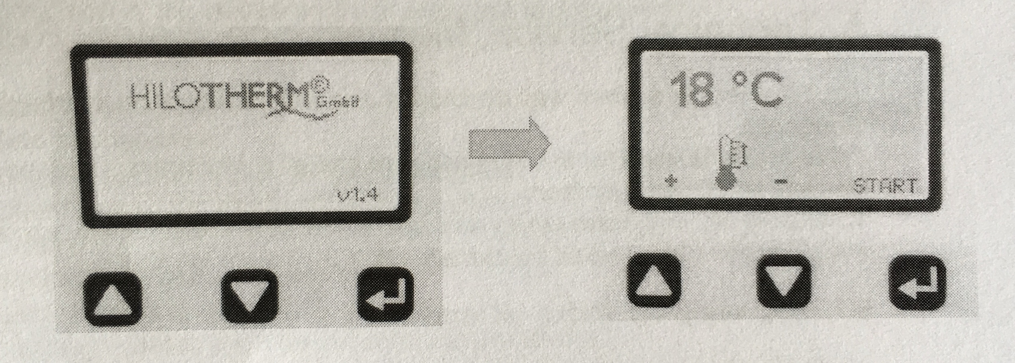
Main switch on
Device is ready
Pressure pump off
Cooling off
Device in operation
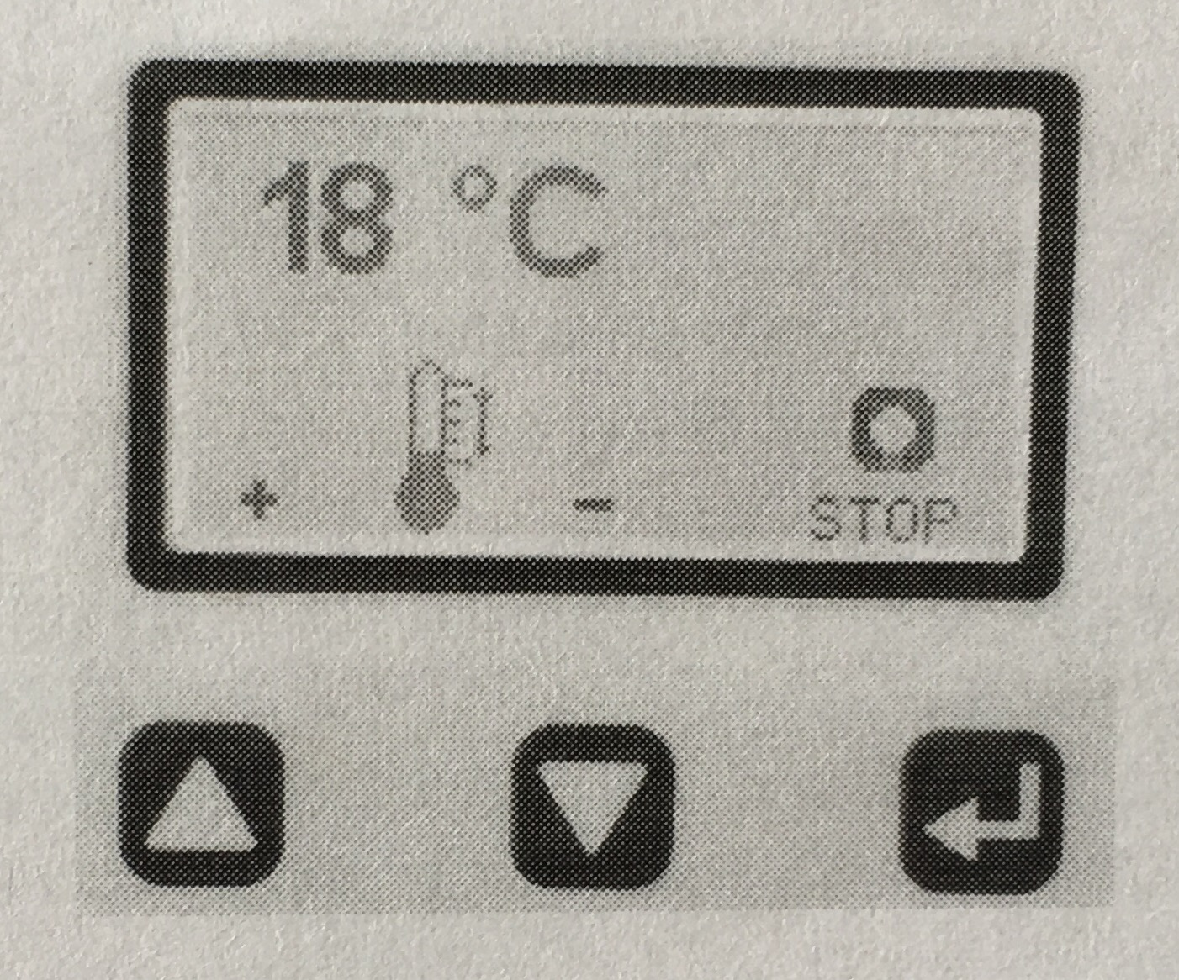
Device cools
Pressure pump running
The temperature can be changed in both operating states.
Trouble-Shooting
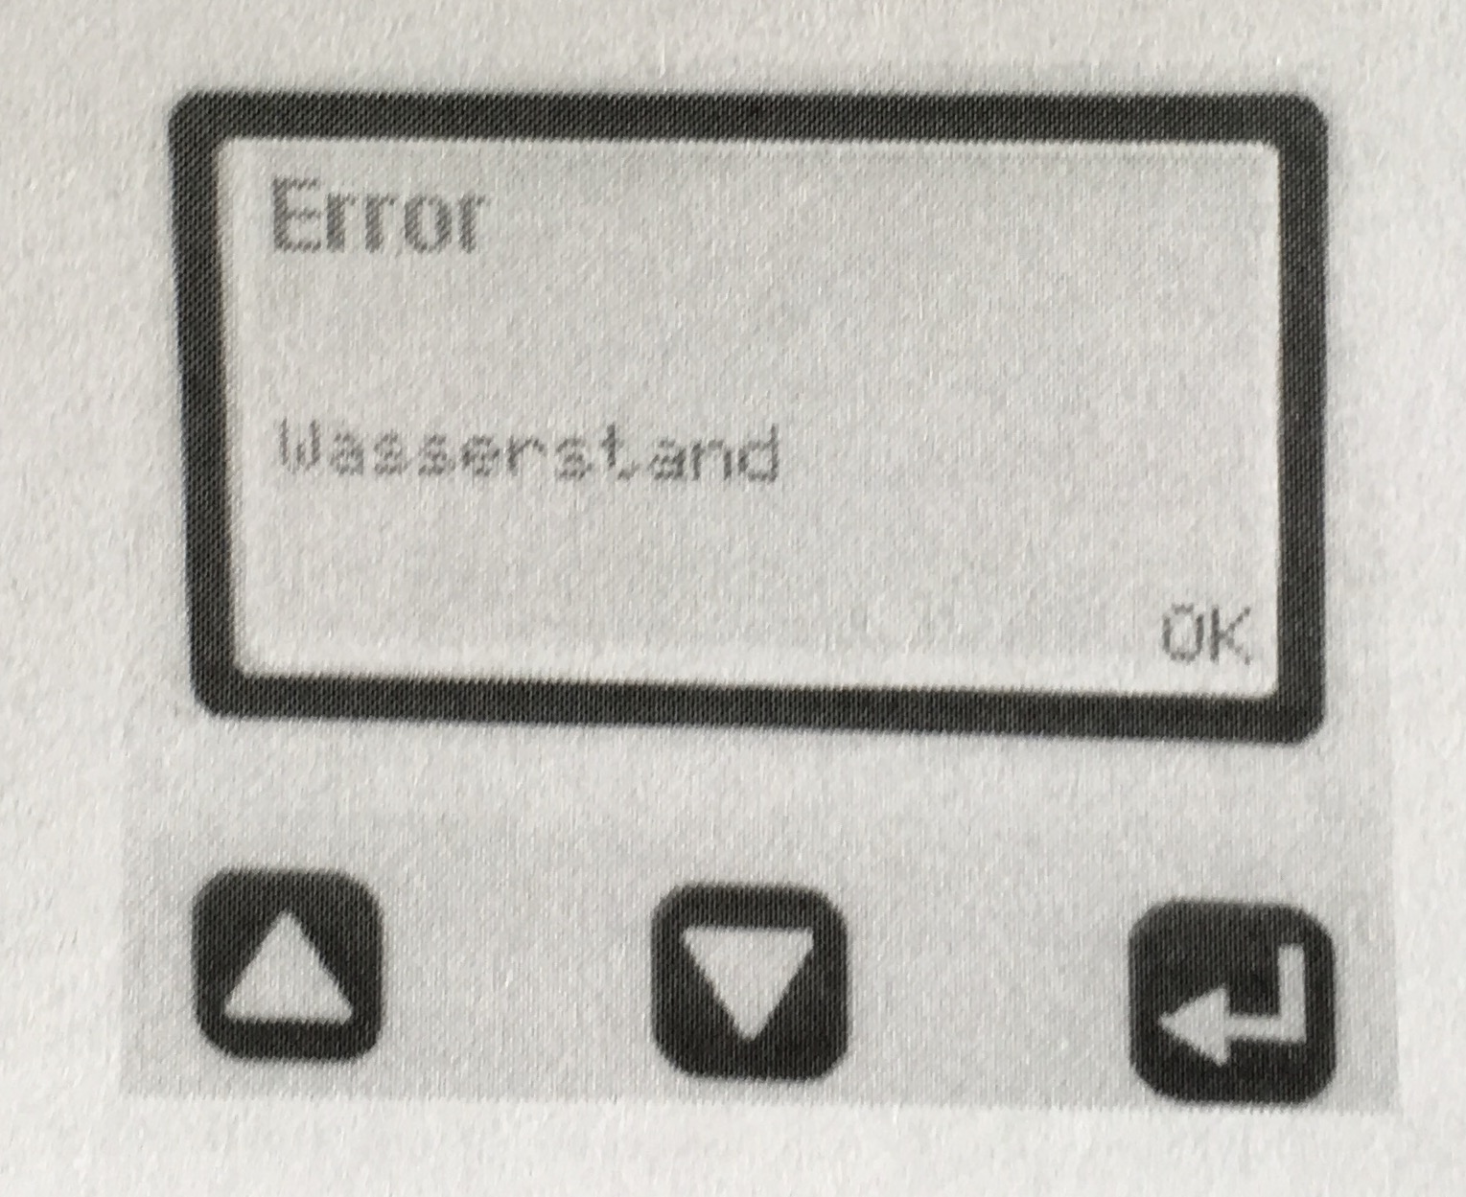
If a malfunction occurs, the word "Error" appears on the display; only the current malfunction is displayed. The display can be deleted with "Start" only after remedying the malfunction.
4. Cleaning and Disinfection
4.1 General
Attention! Make sure to disconnect the device from the mains before cleaning! Do not use sharp objects for cleaning.
4.2 Machine surface
Surfaces and parts of the device can be cleaned with standard household cleaning agents for cleaning plastic surfaces.
Make sure that no fluids enter the device, in particular through the venting slots on the machine sides.
4.3 Cuffs / Application parts
See chapter 9.7
5. Technical Service, Maintenance, Safety Related Inspections
The Hilotherapy system was developed and manufactured according to the highest quality standards.
If the device is used for the intended use and all maintenance is done, the device will reach a lifecycle of 10 years or more.
To ensure the long-term safety and operability of the Hilotherapy system, the following maintenance work should be carried out.
5.1 Replacing the Water Filter and Water Exchange - at least every 6 months
- Drain the water off completely.
- If necessary, rinse the tank with disinfectant (z. B. Kohrsolin FF oder Mikrobac von Fa. Bode Chemie) and then rinse it with fresh distilled water.
- Fill up above the hopper with distilled water to which a preserving agent can be added.
5.2 Cleaning the Heat Exchanger - at least every 6 months or if contamination is visible
Dust collecting on the heat exchanger will reduce the cooling performance of the device. The heat exchanger is located behind the ventilation grille, on the right-hand side of the device.
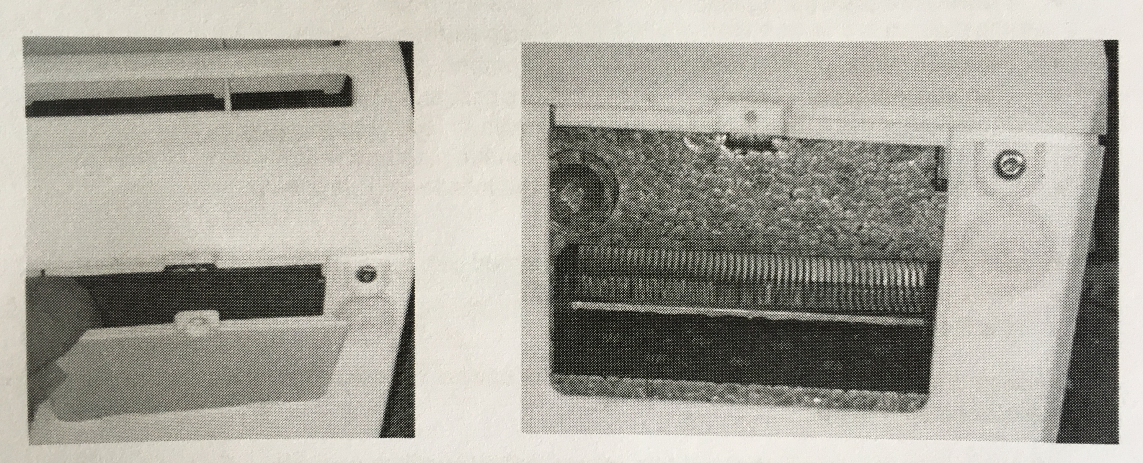
- Remove the fastening screw of the cleaning slot cover.
- Release the latch of the cleaning cover and remove the cover.
- Remove the plug in the cleaning slot.
- Clean the fins of the heat exchanger carefully with a small brush (similar to a toothbrush). If necessary, remove the loose dust from the channel with the pointed nozzle of a vacuum cleaner
- Caution: The cooling plates on the heat exchanger must not be damaged!
- Refit the device components that have been removed in reverse order after cleaning.
5.3 Greasing the Plug-in Connections - at least every 6 months
The plug-in connections to the tubes must be greased regularly so that they remain easy to plug in and guarantee that the plug-in nozzles in the couplings engage completely.
- Grease the tips of the plug-in nozzles on the cuff and tube thinly using Vaseline.
- Plug the nozzles in and out of the tube or Hilotherapy device couplings. This transfers the Vaseline onto the O-rings in the couplings.
5.4 Technical Service - at least once every 2 years (for commercial use)
If the device is used commercially (e.g. use in hospitals), an inspection of the device must be carried out every 2 years according to the following guidelines. When used privately, the owner is responsible for the proper condition of the device and can carry out an inspection.
Visual inspection:
- Are the operating instructions complete?
- Is the type plate complete and legible?
- Are all markings and labelling on the device correct and legible?
- Are all machine components securely attached (no loose parts)?
- Is the machine casing intact?
- Are the plug-in cuff connections intact and easy to use?
- Are all switches and buttons working correctly?
- Does the machine master fuse match the type indicated on the device?
- To change fuses pull out the slot. After changing the fuses push the slot in until it snaps into place.
- Is the device’s mains plug with integrated master switch free of defects?
- Is the power cord undamaged?
- Are the device and the accessories kept in a clean condition?
- Are the venting slots and the heat exchanger behind them clean?
- Are the accessories kept in a proper condition?
- Exchange water filter and distilled water.
Functional test:
- Function of the cooling unit: (Temperature of + 15°C with a small cuff achieved at ambient temperature of 22°C)
- Function of the pressure pump: (Is there sufficient flow to the cuffs?)
- Can you detect any wear?: (Unusual noises?)
- Function of the water level sensor: (Water level error message upon switching on the machine with the tank empty?)
- Function of the flow monitoring: kink hose -> Pump stops with beep
In addition, the following inspections can be carried out
- Pressure inspection
- Performance inspections
In case of malfunctions or defects, only put the device into operation again after the problems have been remedied.
Maintenance measures shall only be carried out by qualified personnel. On request, the manufacturer shall support the maintenance personnel with training and technical information.
5.5 Safety Related Inspections
During production, a Safety Related Inspection is carried out within the scope of the final inspection.
In order to maintain operational safety, a further Safety Related Inspection must be carried out if repair work is carried out on electrical systems.
5.6 Liability
HILOTHERM GmbH (as manufacturer) only regards itself liable for effects on safety, reliability and operability of this device, if:
- assembly, upgrading, resetting, modifications or repair work is performed by persons authorised by the manufacturer.
- the parts and components used for repair work, modifications, upgrades or local applications are authorized by the manufacturer.
- the wiring being used for the connection of the device complies with the rules and regulations of the local authorities.
- only accessories authorized by HILOTHERM GmbH are used.
- the device is operated in accordance with the operating instructions.
5.7 Warranty
The provisions of the German Law are applicable with respect to warranty for defects.
The provisions of the law pertaining to the product liability law are not affected in this respect.
6. Storage, Transport, Disposal
6.1 Storage
The device should be stored horizontally on a level surface at a temperature of 1°C to 40°C and 10-93% relative humidity.
Caution: When storing the device below 0°C, the cooling circuit must be emptied completely to prevent damage caused by freezing.
6.2 Transport
Before transport, the device must be emptied completely, to avoid leakage of the cooling water.
6.3 Disposal (WEEE Reg. No. DE 25202195)
The device must not be disposed with commercial waste or regular garbage.
In accordance with product responsibility under the terms of § 22 of the German Circular Economy and Waste Act and the Electrical and Electronic Equipment Act § 2, 2 paragraph 1, the device must be disposed of in a communal collecting point or returned to the manufacturer.
7. Technical Data
7.1 Technical Data Type HTP1
Article No.: 001 00 000
Rated mains voltage range: 230 VAC (210 VAC – 240VAC)
Rated mains frequency range: 50Hz
Power input max: 155VA
Power consumption max.: 0.7A
Protection class: II
Degree of protection for the application part: BF
Type of protection: IP 21
Risk class (93/42 EWG): IIa
Dimensions: 255mm x 240mm x 240mm
Weight: 2.9kg (without water)
Cuff connections: 1
Water tank capacity: min.0.2 liter, max.0.5 liter
Temperature range: + 15°C to +22°C
Pressure Pump
Nominal voltage: 5V
Operating pressure: 0.6bar
Ambient Conditions
Storage temperature: min. > 0°C, max. + 40°C
Storage humidity: 10 – 93% RH non-condensing
Humidity during Operation: +10°C to +26°C
7.2 Icons
On device and packaging, you will find the following icons:
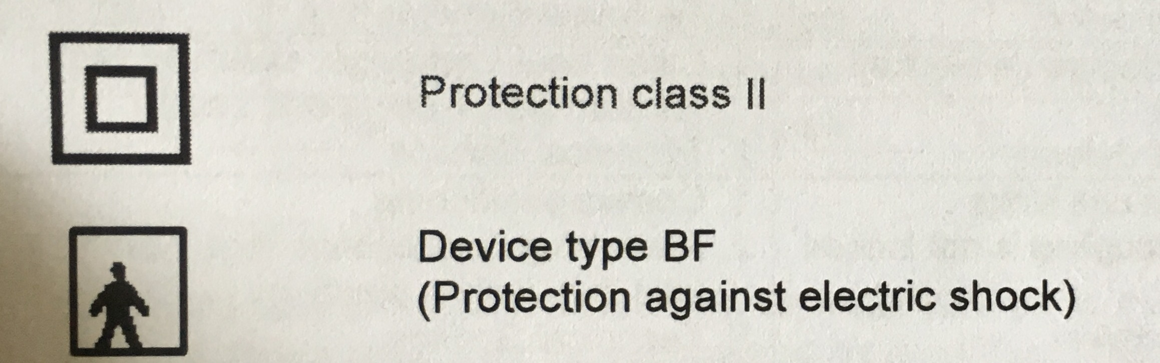
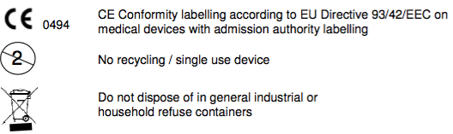
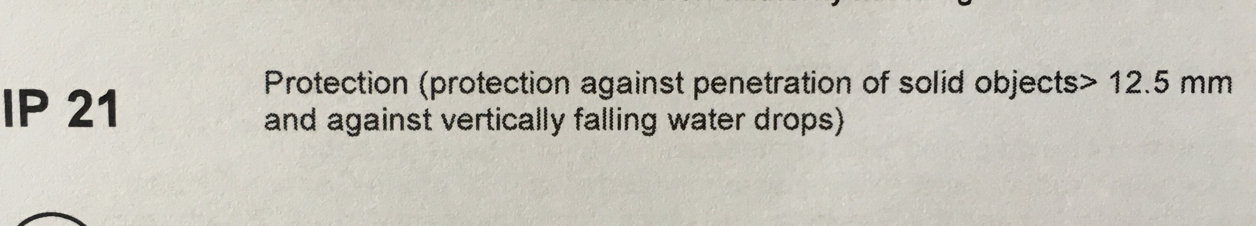
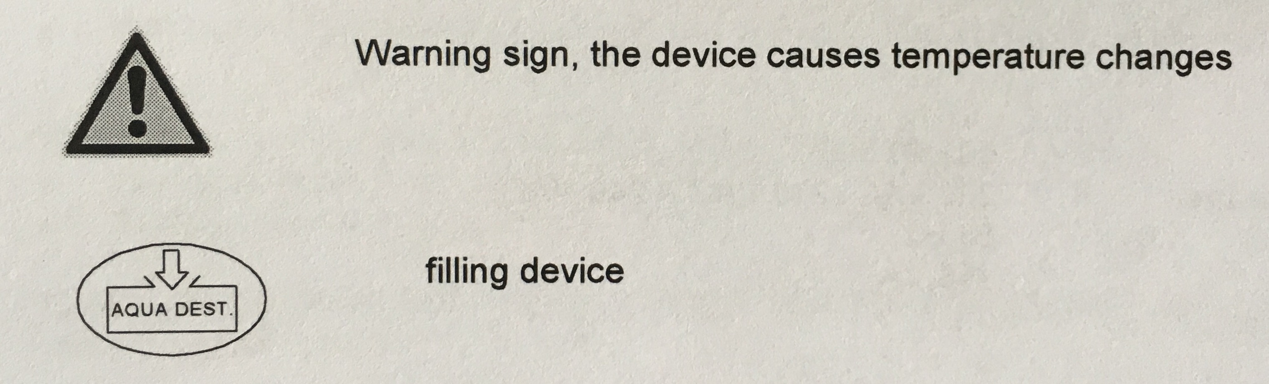
7.3 Safety Standards
Classification
Pursuant to the classification criteria stated in the addendum IX EG-RL 93/42 EEC, the Hilotherapy system is a Class IIa Standard 9 device (active medical product for therapeutical purposes).
In terms of the GMDN classification, the device is assigned to No. P 42463, and the cuffs to No. P 44604.
The Hilotherapy system is neither assigned to Attachment 1 nor to Attachment 2 of the MPBetriebV (Medical Devices Operator Ordinance).
Standards and Guidelines
EC-Directive 93/42/EEC of the council on medical products as of June 14, 1993, Medical Devices Act as of August 2, 1994
DIN EN 60 601-1
DIN EN 60 601-1-2
DIN EN ISO 10993-1
HILOTHERM GmbH retains the right to change specifications without further notice.
7.4 Malfunctions and Troubleshooting
Do not dispose of in general industrial or household refuse containers
Error | Possible Cause | Measures
Device does not work, no display readings | 1. No mains supply  2. Fuse defect  3. Repeated fuse defect  4. Mains plug not connected  5. Device is defect | 1. Switch off device  2. Replace fuse  3. Technical Service  4. Check plug-in connection of the mains  5. Technical Service
No cooling | 1. Heat exchanger is blocked with dust  2. Device is defect | 1. Clean heat exchanger carefully with vacuum cleaner or a soft brush  2. Technical Service
No or insufficient water circulation | - Tubing or cuff kinks  - Plug-in coupling is not locked in place  - Pump is defect | - Correct positioning  - Press plug-in couplings together until they lock in position  - Technical Service
Display reading  “Error water level” | 1. Insufficient water in tank  2. Water level indicator arrest | 1. Replenish with distilled water 2. Remove water and fill up again
Display reading  “Error pump” | 1. Pump defect | 1. Technical Service/ Repair
Display reading  ”ERROR  Temperature sensor W | - Temperaure sensor has short circuit  - Temperature sensor interrupted | 1. Technical Service/ Repair

Display reading  ERROR  overtemperature | - Device component defective  - Ambient temperature is too high (>>35°C) | - Technical service/ repair  - Cool down device and restart
Display reading  ERROR  Temperature falling below | - Device component defective  - Start at ambient temperature is too low (<<4°C) | 1. Technical service/ repair
Display reading  ERROR  Flow  (Incl. Beep when switching off) | - cuff or supply hose kinked  - cuff applied to tightley  - motor blocked | - Remove the kink and restart  - cuff loose application and restart  - check the motor/ repair
Plug-in connection of the tubing difficult to insert | 1. O-ring not lubricated  2. Plug-in connection damaged | 1. Lubricate plug-in nozzle with Vaseline  2. Technical Service
Display reading  ERROR  Device overheats | - Heat exchanger is blocked with dust  - Ambient temperature too high (>> 35°C)  - Air circulation is impeded | 1. Techincal service/ repair
Display reading  ERROR  Temporature Sensor L | - Temperature sensor has short circuit  - Temperature sensor interrupted | 1. Technical service/ repair
Display reading  ERROR  Peltier | - Peltier element has short circuit  - Peltier element has interrupted | 1/2. Techinical service/ repair
Display reading  ERROR  fan | - Fan has short circuit  - Fan has interrupted | 1/2. Techinical service/ repair

Attention! Opening up of the device results in the loss of warranty and liability claims!
8. Accessories and Spare Parts
Any accessories and spare parts are available at HILOTHERM GmbH or your authorised dealer.
Accessories
Only use original HILOTHERM parts and accessories.
Attention! You must not use any other devices or accessories in combination with the Hilotherapy device.
Standard accessories list
Qty | Article number | Description
1 | 40000332 | Power cord (C, F, 230V 50 Hz)
2 | 40000259 | Duo hose
Spare Parts
Only the use of original spare and replacement parts guarantees the safety and reliability of our device. Parts may only be exchanged by qualified personnel.
The Hilotherapy system is constantly being developed and improved.
It is important for you to provide us with the following details so that you will always receive the adequate spare part, even if there have been technical changes.
Name HTP1
Article No. 001 00 000
Serial No.
Year of manufacture
9. Cuffs
9.1 Accessories/ cuffs HTP1
Cuffs for thermo-therapeutic applications in anatomically adapted forms:
- Eye cuff
- Eye cuff, open
- Universal cuff
- Nose cuff
- Nose cuff T-cast
- Upper Face cuff
- Lower Face cuff with link
- Lower Face cuff without link
- Round cuff, small
- Round cuff
- Surface cuff, small
- Knee cuff
- Foot cuff
- Hand cuff
- Trapezoidal cuff
Due to the continuous development it is possible that certain cuffs are removed from the range while new ones are added to it. A current list is available on the web under hilotherapie.com.
Material properties:
Cuff material: Thermoplastic Polyurethane (TPU) - latex-free
Tubing: Thermoplastic Polyurethane (TPU)
Plug-in nozzle: Nickel-plated brass / POM
9.2 Warnings
- The cuffs shall only be used when attached to the Hilotherapy device.
- Cuffs must not be brought into contact with chemicals containing benzol and phenol.
- In case of damage to the cuff’s tubing and capillary system, the cuffs are to be discharged.
- When connecting / disconnecting the duo hose to / from the cuffs, a small amount of water may leak from the device. Make sure that this water does not come into contact with wound dressings and bandages!
- A resterilisation of used cuffs (e.g. with the Ethylenoxide procedure) is not possible.
- Eye cuffs must not exert pressure on the eye!
9.3 Fields of Application on the Patient / Specific Function
- The cuffs are only intended for external application.
- The cuffs are placed on respective skin areas either on top of dressings or directly on intact skin.
- The cuffs are used in the treatment and alleviation of injuries, diseases and their after-effects and their mild and constant cold may be applied after operative interventions.
- In repeated therapeutical applications we recommend a patient-related allocation of a certain cuff.
- Single-use cuffs are for single use only and must not be reprocessed!
9.4 Risk classification of medical products in accordance with RKI guidelines
Risk assessment and evaluation shall be in accordance with Federal Health Gazette No. 44 (2001): 1115-1126: Hygiene Requirements in processing medical products. It is the owner’s responsibility that recycling measures are carried out by qualified persons using a suitable and validated procedure.
The individual recycling steps shall be matched to
- the medical product
- the recycling type
- the application on the patient.
The cuffs are only intended for contact with intact skin. Make sure to place wound dressings on pathologically altered skin areas (e.g. abrasions, infective wounds ...) prior to cold treatment.
With regard to the type of application of the cuffs and the related risk, these are classified as uncritical medical product.
External application of the cuffs on intact skin (e.g. within the scope of physiotherapeutic and rheumatologic treatments) or on top of a wound dressing (e.g. post-operatively within the scope of plastic surgery, vascular surgery, ENT ...).
9.5 Description of Application
For the individual application on certain body areas, choose a suitable cuff form and connect the cuff to the Hilotherapy device in accordance with the instructions given in the manual (see point 3.6). When connecting or disconnecting the tube plug-in nozzles to the Hilotherapy device, several drops of water may leak from the device. Make sure that these drops do not come into contact with wound dressings and bandages!
When full, place the cuff gently and without exerting any pressure (especially significant for eye cuff use!) on the body parts to be treated. It may be necessary to hold the cuffs in place using strips or bandage.
The duration of the treatment must comply with the orders of the attending physician.
9.6 Storage and Transport
The cuffs are delivered under low-germ conditions, sealed in a transport and dust-protection bag and packed into an outer shipping carton. Make sure to store the cuffs in a dust-free and dry environment at consistent room temperature without UV radiation.
9.7 Disinfection, Cleaning and Drying
Cuffs which are marked as single use can not be purified.
Disinfection is required prior to the application of the cuffs on wound dressings.
Purification
Cuffs which are not marked with single use can be purified.
Manual cleaning and disinfection of uncritical medical products
After finishing the treatment, manually clean and disinfect the cuffs with the approved cleaning and disinfectant agents commonly used in clinics (e.g. Kohrsolin FF or Mikrobac by Bode Chemie).
Have a qualified person carry out the wiping disinfection (two-bucket-method). Please observe the manufacturer’s instructions with regard to concentrations and application time of the disinfection agent. The owner of the Hilotherapy system needs to establish a hygiene and disinfection plan with operational sequence descriptions and operation instructions as part of quality management, so that it is possible to document a traceable and validated recycling process.
Automatic cleaning and disinfection of uncritical medical products
Cleaning, disinfection, rinsing and drying may be carried out in a cleaning and disinfection automat using a validated chemical or chemical-thermal process not in excess of 55 °C.
Fixate the cuff within the device chamber with suitable attachments in such a way that the cuff surface is immersed completely in the cleaning and disinfectant medium. This procedure should immediately be followed by an automatic drying process within the device.
It is important that the automatic procedure is carried out by qualified persons and in accordance with quality management guidelines (operational sequence description, operation and procedural instructions) of the owner.
9.8 Checkup
After successfully cleaning and disinfecting the cuffs, carry out a visual inspection and checkup on the cuffs. If the cuff foil, tubing and / or plug-in nozzles are damaged, the cuff needs to be discharged.
In case of residual dirt, repeat cleaning and disinfection procedure in accordance with the hygiene guidelines (see point 9.7).
Prior to applying the cuff to the patient, the cuff must be attached to the Hilotherapy device and filled up to check for leaks.
9.9 Sterilisation
The cuffs cannot be sterilised.
10. Annex
A Guidelines and Manufacturer’s Declaration A1
Table 1 (IEC 60601-1-2:2007)
1 | Guidelines and Manufacturer’s Declaration on Electromagnetic Emissions
2 | The Hilotherapy system is designed for use in an electromagnetic environment specified below. The customer or user of Hilotherm Homecare should ensure that it is operated in such an environment.
3 | Interference emission measurement | compliance | Guideline for electromagnetic environment
4 | HF-emissions compliant with CISPR 11 | Group 1 | The Hilotherapy system uses only HF-energy for its internal functions. Thus, its HF-emissions are very low and it is improbable that it will interfere with the operation of neighbouring devices.
5 | HF-emissions compliant with CISPR 11 | Class B | The Hilotherapy system is designed for the use in all facilities as well as living quarters, including those facilities connected to a power supply that also serves residential buildings.
6 | Emission of harmonic waves compliant with IEC 61000-3-2 | Class A
7 | Emission of voltage surges/flickers complying with IEC 61000-3-3 | EN 61000-3-3
A2
Table 2 (IEC 60601-1-2:2007)
Guidelines and Manufacturer’s Declaration on Electromagnetic Noise Immunity
The HTP1 is designed for use in ambient conditions as described below. The customer or operator of the HTP1 has to make sure the system is being used in such an environment.
Noise immunity checks | IEC 60601 – Test level | Corresponding level | Guidelines for Electromagnetic Environment
Discharge of static electricity (ESD) in compliance with IEC 61000-4-2 | ± 6 kV contact discharge  ± 8kV air discharge | ± 6 kV Contact discharge  ± 8 kV air discharge | The flooring should be wood, concrete or ceramic tiles. If the flooring consists of synthetic material, relative humidity should at least be 30%.
Rapid transient electrical interferences/bursts in compliance with IEC 61000-4-4 | ±2kVfor mains connection  ± 1 kV for input and output connections | ± 2 kV  for mains connection  not applicable | The quality of the supply voltage should meet the standards for typical commercial or clinical environments.
Surges in compliance with IEC 61000-4-5 | ± 1 kV line to line  ± 2 kV line to Earth | ± 1 kV line to line  ± 2 kV line to Earth | The quality of the supply voltage should meet the standards for typical commercial or clinical environments
Voltage drops, short disconnections and surges of the supply voltage in accordance with IEC 61000-4-11 | < 5% Ut (>95% drop Ut) for half cycle  40% Ut (60% drop of Ut) for 5 cycles  70% Ut (30% drop of Ut) for 25 cycles  5% Ut (95% drop of Ut) for 5s | 0% Ut  40% Ut  70% Ut  5000mS | The quality of the supply voltage should meet the standards for typical commercial or clinical environments.  Should the operator of the Hilotherapy system require continued operation in the event of power blackout, we recommend supplying the Hilotherapy system via an interruption-free power supply or battery.
Magnetic field with power frequency at 50/60 Hz in accordance with IEC 61000-4-8 | 3 A/m | 3 A/m | Magnetic fields induced by power frequency should correspond with the values that are typical for commercial or clinical environments.
Footnote: UT describes the mains AC voltage prior to applying the test levels.
A3
Table 4 (IEC 60601-1-2:2007)
Guidelines and Manufacturer’s Declaration – Electromagnetic Noise Immunity
The HTP1 is designed for use in ambient conditions as described below. The customer or operator of the HTP1 has to make sure the device is being used in such an environment.
Noise immunity checks | Noise immunity Test level | Corresponding level | Guidelines for Electromagnetic Environment
Conducted HF- disturbance compliant with IEC 61000-4-6  Radiated HF- disturbances compliant with IEC 61000-4-3 | 3 V eff  150 kHz to 80 MHz  3 V/m  80 MHz to 2,5 GHz | V1 = 3 V  E1 = 3 V/m | The distance from the Hilotherapy system including its supply lines to any portable and mobile kind of radio equipment should not be less than the recommended protection distance that is calculated from the equation for the transmitted frequency.  Recommended protective distance:  with P as the nominal performance of the transmitter in Watt (W) due to the data given by the manufacturer of the transmitter and d being the recommended protective distance in metres (m).  Due to a field survey (a), the field strength of stationary radio transmitters in all frequencies should be less than the corresponding level (b).  In the vicinity of devices being marked with the following icon, interferences may occur.
Footnote 1: For 80 MHz and 800 MHz, the higher frequency range applies.
Footnote 2: These guidelines may not be applicable in all cases. The expansion of electromagnetic fields is also affected by absorptions and reflexions of buildings, objects and persons.
a) In theory, it is not possible to predict the exact field strength of stationary transmitters such as wireless phone base stations, mobile transmitting stations, amateur radio stations, AM and FM broadcasting and television stations. Therefore, a survey of the location should be considered to evaluate the electromagnetic ambient environment with regard to stationary transmitters. If the measured field strength of the location using the Hilotherapy system exceeds the corresponding levels stated above, the device should be closely observed to establish whether it is working as intended. In case the device is observed to have unusual capability features, additional steps may be necessary, e.g. realigning or relocating the Hilotherapy system.
b) Within the frequency range of 150 kHz to 80 MHZ the field strength should be less than [V1] V/m.
A4
Table 6 (IEC 60601-1-2:2007)
Recommended Protection Distances between portable and mobile HF telecommunications devices and the Hilotherapy system
The HTP1 is intended for use in electromagnetic environments with controlled HF disturbances. The customer or user of the HTP1 can positively influence the situation by observing a minimum distance between the HPT1 and portable and mobile HF telecommunication devices (transmitters) – depending on the output power of the communication device (as shown below).
Power rating of the transmitter W | Protective distance, depending on the transmitting frequency M
 | 150 kHz to 80 MHz | 80 MHz to 800 MHz | 800 MHz to 2,5 GHz
0.01 | 0.12 | 0.12 | 0.23
0.1 | 0.37 | 0.37 | 0.74
1 | 1.17 | 1.17 | 2.33
10 | 3.70 | 3.70 | 7.37
100 | 11.70 | 11.70 | 23.33
For those transmitters whose power rating is not indicated in the table above, the recommended protective distance d in metres (m) may be calculated using the corresponding equation in the particular column, with P being the maximum power rating of the transmitter in Watt (W) (according to transmitter manufacturer’s data).
Footnote 1: For 80 MHz and 800 MHz, the higher frequency range applies.
Footnote 2: These guidelines may not be applicable in all cases. The expansion of electromagnetic fields is also affected by absorptions and reflexions of buildings, objects and persons.

